PHARMACY OPTIMIZATION TEAM • QUALITY ASSURANCE
WEEK 1

VACS AI Patient & Grading Issue Report
Consolidated Clinical & Operational Audit | Tuesday–Thursday
Maria Gonzalez (MG) • James Wilson (JW) • Linda Martinez (LM)
Prepared by Mitchell Bowers, PharmD Candidate, Class of 2027, D’Youville University School of Pharmacy
Compiled 20 October 2026 | Source initial audits 15–19 October 2026

Purpose and evidence standards
This Week 1 developer handoff consolidates the nine supplied visit-specific audits into one report. Each patient appears Tuesday initial visit, Wednesday 3-month follow-up, then Thursday 6-month/final follow-up. Following the Week 3 model, findings are grouped by underlying problem and limited to case data, simulated-patient behavior, rubric/AI-grader contradictions, or verification-worthy scoring issues. Routine SOAP writing suggestions are not counted as defects.
Evidence priority: student-facing current EMR for objective data; actual AI-patient statements for subjective facts; short grading checklists for stated learning priorities only; AI-grader feedback as claims to verify. Historical records supply trends but never replace current answers. Confirmed means visible in the supplied source audits; it does not imply a backend root cause has been reproduced. Screenshots reused here come from original live/AI-interview/grader evidence already embedded in the uploaded reports, rather than newly fabricated exhibits.

Quick Guide for Non-Clinical Readers
Term | Plain-language meaning
VACS / AI patient | Virtual Ambulatory Care Simulation and the conversational simulated patient.
EMR / SOAP | Electronic medical record; subjective, objective, assessment and plan note.
Rubric / AI grader | Expected assessment criteria and software that assigns a score.
A1C / LDL-C | Average blood sugar over ~2–3 months; LDL (“bad”) cholesterol.
BP / UACR | Blood pressure; urine albumin-to-creatinine ratio, a kidney-risk marker.
SCr / eGFR | Serum creatinine; estimate of kidney filtration.
BSA (Mosteller) | Body-surface area calculated from height and weight.
CKD G3aA3 → A2 | Kidney filtration stage G3a; albuminuria A3 is severely increased and A2 moderately increased.
SGLT2i / GLP-1 RA | Diabetes medicine classes that can offer additional heart/kidney benefits.
ASCVD / MI / PCI | Atherosclerotic heart/vascular disease; heart attack; coronary stent procedure.
Confirmed / review | Observed cross-source disagreement / possible mismatch pending source or scoring validation.

Final Review Summary
The nine encounter audits identify 25 grouped findings or verification items. They are not 25 proven software defects: some concern confirmed contradictory source values, some require reference-version/score checks, and others reflect clinically debatable grading specificity. Repeated patient-level problems are cross-referenced between visits instead of presented as independent root causes.
Encounter | Stage | AI grader score | Grouped items
Maria Gonzalez (MG) — Tuesday | Initial visit | 95.6% (Strong) | 1
Maria Gonzalez (MG) — Wednesday | 3-month follow-up | 88.1% (Strong) | 1
Maria Gonzalez (MG) — Thursday | 6-month follow-up | 92.2% (Strong) | 0
James Wilson (JW) — Tuesday | Initial visit | 94.2% (Strong) | 3
James Wilson (JW) — Wednesday | 3-month follow-up | 90.6% (Strong) | 5
James Wilson (JW) — Thursday | 6-month follow-up | 95.6% (Strong) | 2
Linda Martinez (LM) — Tuesday | Initial visit | 94.6% (Strong) | 4
Linda Martinez (LM) — Wednesday | 3-month follow-up | 83.4% (Solid) | 6
Linda Martinez (LM) — Thursday | 6-month / final follow-up | 91.3% (Strong) | 3

Counts: MG 2 items (Tuesday 1, Wednesday 1, Thursday 0); JW 10 items (Tuesday 3, Wednesday 5, Thursday 2); LM 13 items (Tuesday 4, Wednesday 6, Thursday 3). Sum: 25. Individual penalties within one reference mismatch are grouped to prevent inflated issue counts.

Priority patterns and recommended fix order
1. First align live EMR with grader answer keys. MG Wednesday: seven laboratory mismatches (3.7 disputed points); JW Wednesday: six laboratory mismatches (3.1); LM Wednesday: LDL-C 76 versus expected 86 (1.0).
2. Align AI-patient dialogue and visit-specific grader expectations. JW Wednesday: adherence, glucose, exercise and family-history assumptions (2.3 disputed points). LM Wednesday: expected missed doses and unverifiable home readings; MG Tuesday: follow-up scheduling disagreement.
3. Correct or investigate patient-record integrity. JW and LM age/DOB conflicts; Mosteller BSA calculations; JW family stroke age, home BP provenance, glucose-meter continuity and SGLT2 symptom contradictions; LM home-monitoring provenance and final-visit metadata.
4. Review grading criteria that may demand inaccessible precision or single-path clinical decisions. Exact Tdap intervals, UACR “improving” versus stable wording, walking not reported, and finerenone versus lipid priorities should be checked against what students could actually see.
5. Obtain raw scoring rules before claiming arithmetic defects. LM Tuesday, Wednesday and Thursday show small visible-subtotal differences; current posted percentages are retained pending verification.

Acceptance standards for regression testing
Retest all nine visits in patient/day order after changes. Keep the original SOAP and interview transcript fixed during regrades. Verify source-version identifiers, exact objective values, coherent longitudinal history, correct visit stage, and every affected criterion; record before/after grader output. Do not treat a rubric-only reference value as proof the AI patient actually provided it.

PATIENT A / MG

Maria Gonzalez — Weekly Audit
Tuesday initial visit → Wednesday 3-month follow-up → Thursday 6-month/final follow-up. Each subsection below preserves the grader score and resolution status from the supplied visit-specific report.

Maria Gonzalez — Tuesday Initial visit
AI-grader: 95.6% (Strong) | Grouped issues/review items: 1 | Initial audit, not post-fix retest
ID | Issue | Priority | Source-based disposition
MG-TUE-01 | Follow-up timetable conflicts with grader | Medium | Checklist–grader conflict; developer review

MG-TUE-01 | Follow-up timetable conflicts with grader
PRIORITY: MEDIUM STATUS: Checklist–grader conflict; developer review
What the student saw or heard: Student-facing checklist says to plan approximately 1-month follow-up. Student SOAP plans pharmacist follow-up in ~4 weeks, A1C in ~3 months, and lipids 4–12 weeks after statin initiation.
What the reference / grader expected: The grader instead requires an explicit ~3-month pharmacist visit and penalizes 4H.1 (−0.6), 4H.3 (−0.2) and 4H.5 (−0.2): 1.0 point across three related criteria.
Why this is a problem: Two clinically distinct visits (early medication/BP check, later laboratory review) are treated as incompatible rather than complementary. Root cause cannot be determined without full hidden rubric.
Suggested developer fix / retest: Align the checklist and grading rule. Permit a ~4-week interim pharmacist visit with separately timed ~3-month A1C and 4–12-week lipid monitoring; regression-test the same SOAP against the revised timing model.
Evidence source: Tuesday audit: “MG Tue Initial Report .docx”; original AI feedback 04.
Original AI-grader timing deduction excerpt (criterion 4H.1). [Extracted unchanged from uploaded visit audit.]

Visit conclusion / boundaries
No other Tuesday deductions are elevated without evidence of a system defect.
Source report: MG Tue Initial Report .docx. Score and issue interpretations above are carried forward from this uploaded audit.

Maria Gonzalez — Wednesday 3-month follow-up
AI-grader: 88.1% (Strong) | Grouped issues/review items: 1 | Initial audit, not post-fix retest
ID | Issue | Priority | Source-based disposition
MG-WED-01 | Seven laboratory answer-key values differ from student-facing EMR | High | Confirmed EMR–grader reference mismatch

MG-WED-01 | Seven laboratory answer-key values differ from student-facing EMR
PRIORITY: HIGH STATUS: Confirmed EMR–grader reference mismatch
What the student saw or heard: The current Wednesday EMR and submitted SOAP agree: Na 139 mmol/L; K 4.3 mmol/L; SCr 0.90 mg/dL; eGFR 82 mL/min/1.73 m²; total cholesterol 158 mg/dL; HDL-C 48 mg/dL; triglycerides 160 mg/dL.
What the reference / grader expected: Grader expected, respectively, 138, 4.4, 0.95, 74, 170, 45, and 180; deducted 3.7 points across criteria 2B.4/2B.5/2B.6/2B.7/2B.9/2B.11/2B.12.
Why this is a problem: A student is penalized for transcribing the displayed clinical record accurately. SCr/eGFR changes can affect clinical judgment.
Suggested developer fix / retest: Rebind all seven Wednesday lab criteria to the learner-visible case revision; regrade the unchanged SOAP and verify all seven reference-driven deductions disappear, leaving unrelated grading unchanged.
Evidence source: Wednesday audit: “MG Wed Initial Report.docx”; live EMR excerpts and original AI feedback.
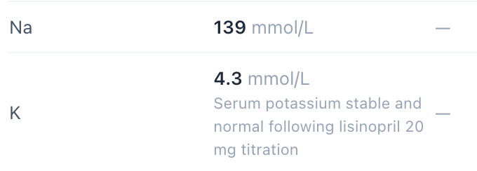
Live Wednesday EMR excerpt: sodium 139 and potassium 4.3. [Extracted unchanged from uploaded visit audit.]
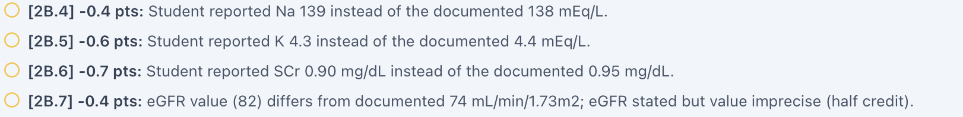
Original grader feedback uses different renal/electrolyte expected values. [Extracted unchanged from uploaded visit audit.]

Visit conclusion / boundaries
The complete Wednesday patient interview was not supplied in the source audit; no unsupported interview findings are inferred.
Source report: MG Wed Initial Report.docx. Score and issue interpretations above are carried forward from this uploaded audit.

Maria Gonzalez — Thursday 6-month follow-up
AI-grader: 92.2% (Strong) | Grouped issues/review items: 0 | Initial audit, not post-fix retest

No confirmed new system or grading findings
This visit was reviewed and retained in the complete weekly sequence even though it does not support an independently actionable developer defect.

Visit conclusion / boundaries
No new confirmed system, AI-patient or grading mismatch in this audit. Seventeen rubric deductions concern documentation specificity (adherence language, diabetes improvement factors, HTN/ASCVD framing, preventive care and GLP-1 RA counseling). They are not developer bug tickets. The visible deduction total is 7.9 points, while posted grade is 92.2%; rounding/aggregation was not independently audited.
Source report: MG Thu Initial Report.docx. Score and issue interpretations above are carried forward from this uploaded audit.

PATIENT B / JW

James Wilson — Weekly Audit
Tuesday initial visit → Wednesday 3-month follow-up → Thursday 6-month/final follow-up. Each subsection below preserves the grader score and resolution status from the supplied visit-specific report.

James Wilson — Tuesday Initial visit
AI-grader: 94.2% (Strong) | Grouped issues/review items: 3 | Initial audit, not post-fix retest
ID | Issue | Priority | Source-based disposition
JW-TUE-01 | Age conflicts with displayed date of birth | Medium | Verified chart-content inconsistency
JW-TUE-02 | Mosteller BSA does not match recorded measurements | Medium | Verified chart-calculation inconsistency
JW-TUE-03 | Father’s fatal-stroke age differs in EMR versus interview | Medium | Verified EMR–AI-patient source contradiction

JW-TUE-01 | Age conflicts with displayed date of birth
PRIORITY: MEDIUM STATUS: Verified chart-content inconsistency
What the student saw or heard: Patient header states a 62-year-old man and DOB 03/12/1972; encounter shown 06/23/2026.
What the reference / grader expected: The provided DOB yields age 54 on that date, not 62. No grader-specific wrong-age deduction is proven.
Why this is a problem: Age-dependent preventive care and treatment logic could be driven by the wrong demographic field.
Suggested developer fix / retest: Determine canonical synthetic DOB/age, synchronize all patient-facing fields and age-dependent rubric rules; retest both display and downstream age calculations.
Evidence source: Tuesday audit “JW Tue Initial Report.docx”; original live header capture.
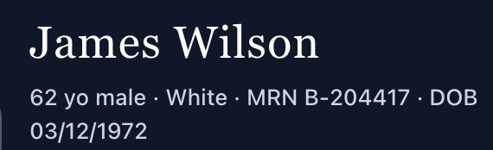
Original patient-header capture shows age and DOB side-by-side. [Extracted unchanged from uploaded visit audit.]

JW-TUE-02 | Mosteller BSA does not match recorded measurements
PRIORITY: MEDIUM STATUS: Verified chart-calculation inconsistency
What the student saw or heard: Displayed height 5 ft 10 in (177.8 cm), weight 101 kg, Mosteller BSA 2.04 m².
What the reference / grader expected: Mosteller BSA = sqrt[(177.8 × 101)/3600] ≈ 2.23 m².
Why this is a problem: Derived anthropometric value is inconsistent with the documented inputs; no BSA-based therapy was implicated in this visit.
Suggested developer fix / retest: Verify unit conversions, formula, cached value and visit-specific weights. Recalculate from the displayed measures and confirm 2.23 m² (approximately).
Evidence source: Tuesday audit; original live vitals captures.

JW-TUE-03 | Father’s fatal-stroke age differs in EMR versus interview
PRIORITY: MEDIUM STATUS: Verified EMR–AI-patient source contradiction
What the student saw or heard: Tuesday EMR family history records father’s fatal stroke at age 68. The Tuesday AI-patient interview says the event occurred at 71 and repeats age 71 on clarification.
What the reference / grader expected: A coherent case should use the same father-stroke history in the same encounter. Neither age can be presumed canonical.
Why this is a problem: The discrepancy undermines history documentation and could lead to contradictory student notes even when sources are transcribed faithfully.
Suggested developer fix / retest: Select authoritative case history and synchronize Tuesday EMR and AI-patient state; retest the question and follow-up clarification.
Evidence source: Tuesday audit; original live family-history and AI-patient interview captures.
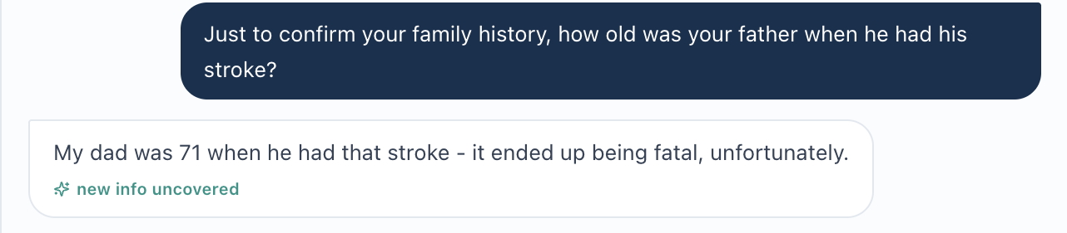
Original interview evidence for father’s stroke-age clarification. [Extracted unchanged from uploaded visit audit.]

Visit conclusion / boundaries
The grader awarded 94.2% (Strong); routine SOAP-specific deductions and a 6–8-week access reassessment preference do not independently prove a grader defect.
Source report: JW Tue Initial Report.docx. Score and issue interpretations above are carried forward from this uploaded audit.

James Wilson — Wednesday 3-month follow-up
AI-grader: 90.6% (Strong) | Grouped issues/review items: 5 | Initial audit, not post-fix retest
ID | Issue | Priority | Source-based disposition
JW-WED-01 | Six laboratory values incorrectly scored against alternate references | High | Confirmed EMR–grader lab mismatch
JW-WED-02 | Five history grading items diverge from Wednesday patient evidence | High | Confirmed interview–grader expectation mismatch (grouped)
JW-WED-03 | Home BP log in chart conflicts with device ownership denial | Medium | Verified current EMR–interview contradiction
JW-WED-04 | Glucose-monitoring history reverses between Tuesday and Wednesday | Medium | Longitudinal AI-patient inconsistency; investigation
JW-WED-05 | Empagliflozin urinary-frequency history differs between sources | Medium | Verified EMR–interview symptom conflict

JW-WED-01 | Six laboratory values incorrectly scored against alternate references
PRIORITY: HIGH STATUS: Confirmed EMR–grader lab mismatch
What the student saw or heard: Wednesday current EMR and submitted SOAP: Na 139 mEq/L; eGFR 84 mL/min/1.73 m²; total cholesterol 172 mg/dL; HDL-C 46 mg/dL; triglycerides 158 mg/dL; UACR 16 mg/g.
What the reference / grader expected: Grader expects 138, 83, 178, 43, 200, and 20 respectively; deducts 3.1 points in 2B.4 (0.4), 2B.7 (0.4), 2B.8 (0.4), 2B.10 (0.4), 2B.11 (0.6), 2B.12 (0.9).
Why this is a problem: Six correctly documented objective values are treated as incorrect, suggesting case-version or answer-key mismatch.
Suggested developer fix / retest: Match six grader answer-key values to Wednesday live EMR source version and regrade the unchanged note; preserve all other penalties until separately reviewed.
Evidence source: Wednesday audit; original EMR/AI feedback screenshots.
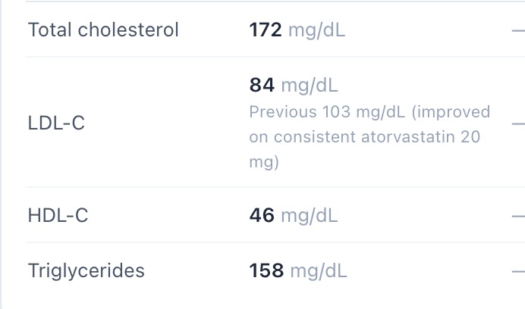
Wednesday live lipid panel: total cholesterol 172, HDL-C 46, triglycerides 158. [Extracted unchanged from uploaded visit audit.]
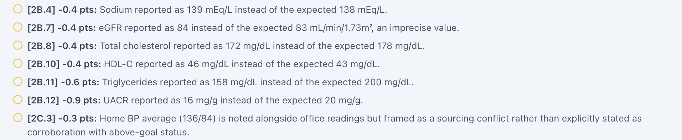
Original AI grader lists the six inconsistent laboratory expectations. [Extracted unchanged from uploaded visit audit.]

JW-WED-02 | Five history grading items diverge from Wednesday patient evidence
PRIORITY: HIGH STATUS: Confirmed interview–grader expectation mismatch (grouped)
What the student saw or heard: Wednesday AI patient: no missed doses in prior two weeks; no home glucose meter or fasting readings; walks 20–30 minutes ~4 days/week; father’s stroke at age 68 (which matches Wednesday EMR).
What the reference / grader expected: Grader expects missed doses every 1–2 weeks (1B.7, −0.4); fasting glucose 140–160 (1B.11, −0.5); walking 15–20 min ~3 days/wk (1B.16, −0.3; 1D.8, −0.5); father’s stroke at 71 (1C.13, −0.6). Combined 2.3 points.
Why this is a problem: The same exercise discrepancy generates two deductions; rubric-only facts should not replace actual interview statements.
Suggested developer fix / retest: Resolve visit-specific expected responses and version mappings. Grade only Wednesday accessible statements and re-evaluate all five criteria without inventing missed doses/home glucose values.
Evidence source: Wednesday audit; original interview and grader feedback.
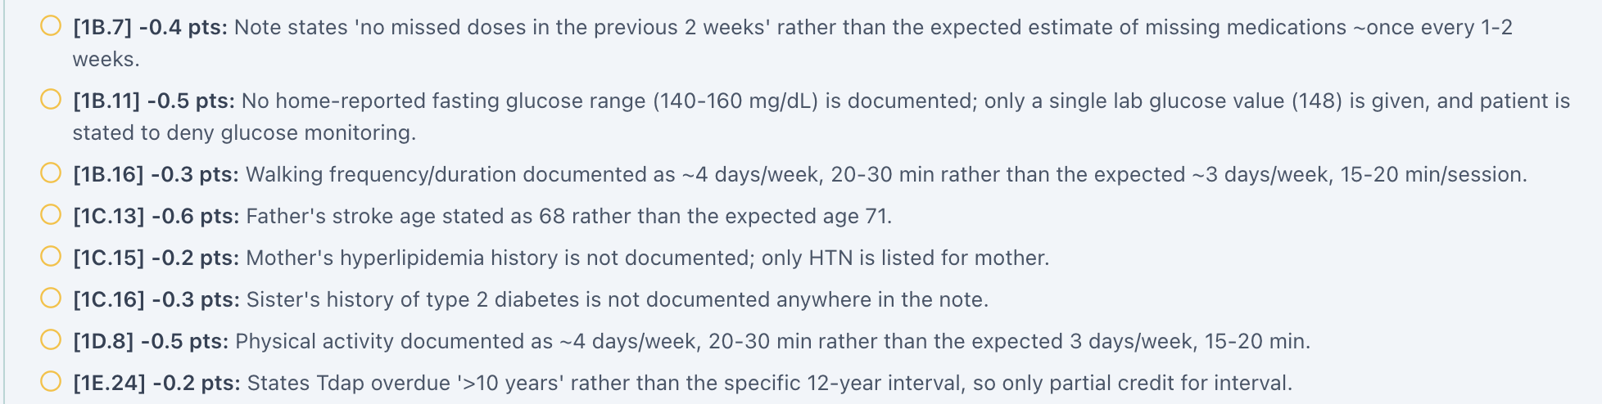
Original grader history deductions including activity, missed doses and stroke age. [Extracted unchanged from uploaded visit audit.]
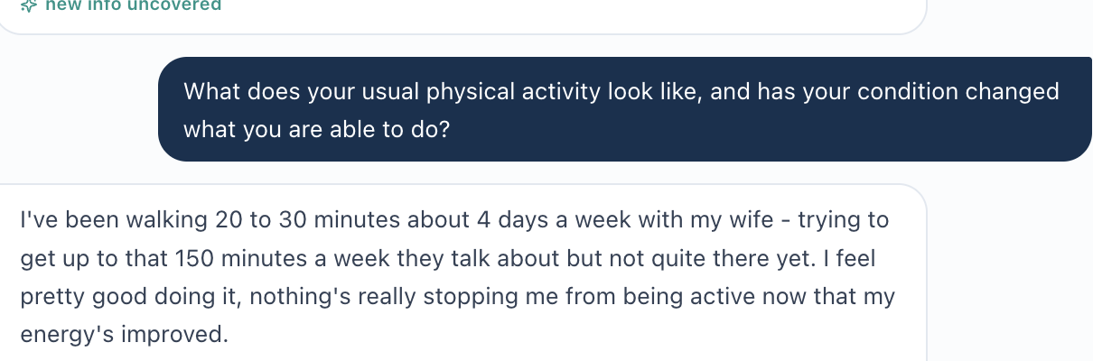
Original Wednesday patient report: walking 20–30 minutes on four days each week. [Extracted unchanged from uploaded visit audit.]

JW-WED-03 | Home BP log in chart conflicts with device ownership denial
PRIORITY: MEDIUM STATUS: Verified current EMR–interview contradiction
What the student saw or heard: Wednesday EMR describes a reviewed home BP average 136/84 mmHg. During interview patient states he has no home BP cuff and obtains readings only at clinic; he reiterates this when asked to clarify.
What the reference / grader expected: The chart implies a measured home BP series, while patient cannot identify a home device or collection process.
Why this is a problem: Unclear measurement provenance can distort BP management and weaken the reliability of documented home-monitoring behavior.
Suggested developer fix / retest: Check actual log origin and whether readings were obtained elsewhere or copied forward. Retain the contradiction until evidence resolves it; never reattribute the EMR value to patient self-report.
Evidence source: Wednesday audit; EMR p.7 and original interview/clarification.

Original patient response: no home blood-pressure cuff. [Extracted unchanged from uploaded visit audit.]

JW-WED-04 | Glucose-monitoring history reverses between Tuesday and Wednesday
PRIORITY: MEDIUM STATUS: Longitudinal AI-patient inconsistency; investigation
What the student saw or heard: Tuesday patient reportedly described self-monitoring fasting sugars 170–200 mg/dL several times weekly. Wednesday patient reports no home meter, denies ever reporting home readings, and relies on clinic labs.
What the reference / grader expected: The longitudinal patient profile should explain interval changes, or at minimum preserve coherent prior-visit memory.
Why this is a problem: Without a device-acquisition/loss narrative, the history may be a conversational memory/state reset rather than a real clinical change.
Suggested developer fix / retest: Review prior visit dialogue and state persistence. Determine device-history timeline; prompt an explicit clarification where needed and test both visits sequentially.
Evidence source: Wednesday audit; cross-visit transcript comparisons.
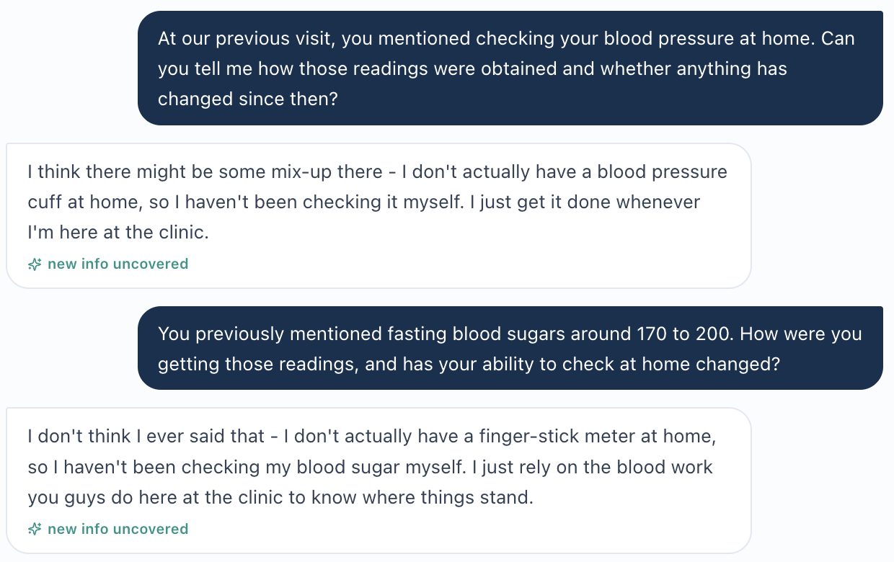
Original Wednesday clarification rejects presumed prior home-monitoring history. [Extracted unchanged from uploaded visit audit.]

JW-WED-05 | Empagliflozin urinary-frequency history differs between sources
PRIORITY: MEDIUM STATUS: Verified EMR–interview symptom conflict
What the student saw or heard: Wednesday EMR denies urinary frequency or urgency related to SGLT2 therapy; Wednesday patient instead describes mildly increased daytime urination after empagliflozin, without infection, dehydration or daily-function impact.
What the reference / grader expected: Patient narrative and current symptom field should agree or explain a temporal distinction.
Why this is a problem: The discrepancy may affect tolerability counseling. Mild urinary frequency is not itself evidence the drug must be stopped.
Suggested developer fix / retest: Reconcile symptom state across chart and simulated patient. Test that learner receives credit for accurately documenting mild frequency and appropriate hydration/infection counseling.
Evidence source: Wednesday audit; EMR symptom summary and clarification.
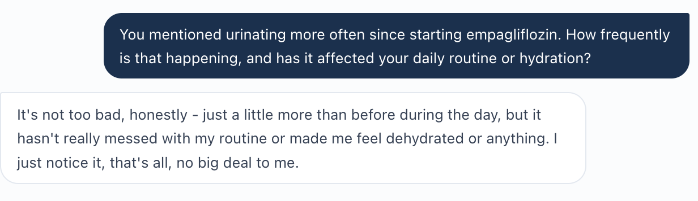
Original empagliflozin symptom clarification: mild extra urination, no dehydration. [Extracted unchanged from uploaded visit audit.]

Visit conclusion / boundaries
These five grouped findings include 11 challenged criterion-level grading deductions (5.4 points) within the first two items. The Wednesday 90.6% score itself reconciles to the 21 visible deductions totaling 9.4 points. Age/DOB and BSA concerns from Tuesday persist but are cross-referenced rather than recounted as new types.
Source report: JW Wed Initial Report.docx. Score and issue interpretations above are carried forward from this uploaded audit.

James Wilson — Thursday 6-month follow-up
AI-grader: 95.6% (Strong) | Grouped issues/review items: 2 | Initial audit, not post-fix retest
ID | Issue | Priority | Source-based disposition
JW-THU-01 | Grader wants an exact Tdap interval not visible in EMR | Medium | Possible rubric/source specificity mismatch; verify
JW-THU-02 | “Improving” UACR wording overlooks latest stability | Low | Possible rubric wording ambiguity; verify

JW-THU-01 | Grader wants an exact Tdap interval not visible in EMR
PRIORITY: MEDIUM STATUS: Possible rubric/source specificity mismatch; verify
What the student saw or heard: The Thursday EMR says Tdap was last administered more than 10 years ago and booster is overdue. The SOAP retains this available specificity.
What the reference / grader expected: Criterion 1E.24 (−0.2) expects an exact 12-year interval. A specific last-dose date is not located in the reviewed Thursday EMR.
Why this is a problem: If 12 years was inaccessible, demanding it rewards invented documentation. The exact interval might exist in another student-visible source; not confirmed.
Suggested developer fix / retest: Check all Thursday vaccine sources available to students. If only >10 years is visible, accept it or expose exact date; otherwise classify as ordinary omission.
Evidence source: Thursday audit; EMR immunization review and original grader feedback.

JW-THU-02 | “Improving” UACR wording overlooks latest stability
PRIORITY: LOW STATUS: Possible rubric wording ambiguity; verify
What the student saw or heard: UACR trajectory is 18 → 16 → 16 mg/g. The chart calls the Thursday 16 mg/g reading normal/low and stable; SOAP did not explicitly give full longitudinal trend.
What the reference / grader expected: Criterion 2C.2 (−0.3) asks for “improving” UACR rather than merely the low/normal value.
Why this is a problem: A description of improvement from baseline and no new change since Wednesday would be the accurate interpretation. A deduction for omitting trend entirely may still be valid.
Suggested developer fix / retest: Clarify whether credit requires comparative trend versus improvement in the most recent interval. Score faithful “decreased from baseline; stable since Wednesday” as correct.
Evidence source: Thursday audit; urine study and feedback item 2C.2.

Visit conclusion / boundaries
No new confirmed Thursday grading defect was identified. Thursday clarification explains that the patient now owns BP and glucose meters, so newer home readings do not require a separate device-history bug. Reuse JW-TUE-01/02 for recurring age and BSA inconsistencies. Other 13 feedback items (3.9 points) are SOAP documentation refinements.
Source report: JW Thurs Initial Report.docx. Score and issue interpretations above are carried forward from this uploaded audit.

PATIENT C / LM

Linda Martinez — Weekly Audit
Tuesday initial visit → Wednesday 3-month follow-up → Thursday 6-month/final follow-up. Each subsection below preserves the grader score and resolution status from the supplied visit-specific report.

Linda Martinez — Tuesday Initial visit
AI-grader: 94.6% (Strong) | Grouped issues/review items: 4 | Initial audit, not post-fix retest
ID | Issue | Priority | Source-based disposition
LM-TUE-01 | Age and DOB inconsistent in patient record | High | Verified chart demographic conflict
LM-TUE-02 | Mosteller BSA differs from height/weight-derived result | Medium | Verified anthropometric calculation discrepancy
LM-TUE-03 | Grader requires “occasional walking” without patient support | Medium | Potential grader/reference mismatch; verify
LM-TUE-04 | Displayed grade and visible penalty subtotal differ 0.1 point | Low | Scoring reconciliation; unverified

LM-TUE-01 | Age and DOB inconsistent in patient record
PRIORITY: HIGH STATUS: Verified chart demographic conflict
What the student saw or heard: LM Tuesday EMR states 68-year-old female, DOB 03/12/1972, and chart encounter 06/23/2026.
What the reference / grader expected: DOB corresponds to age 54 on that date, not 68.
Why this is a problem: Age discrepancy may alter age-dependent clinical and prevention decisions and grader assumptions.
Suggested developer fix / retest: Confirm intended synthetic age/DOB; synchronize all case demographic fields and downstream rules, then test on all three visits.
Evidence source: Tuesday audit; EMR patient header.

LM-TUE-02 | Mosteller BSA differs from height/weight-derived result
PRIORITY: MEDIUM STATUS: Verified anthropometric calculation discrepancy
What the student saw or heard: LM Tuesday displays weight 96 kg, height 5 ft 5 in (165.1 cm), and BSA 2.04 m².
What the reference / grader expected: Mosteller = sqrt[(165.1 × 96)/3600] ≈ 2.10 m²; displayed BMI 35.2 is consistent with the recorded inputs.
Why this is a problem: BSA is inconsistent with named calculation and may represent stale measurements or erroneous units.
Suggested developer fix / retest: Validate formula, patient data mapping and rounding. Refresh BSA on measurement changes and confirm displayed result.
Evidence source: Tuesday audit; EMR anthropometric section.

LM-TUE-03 | Grader requires “occasional walking” without patient support
PRIORITY: MEDIUM STATUS: Potential grader/reference mismatch; verify
What the student saw or heard: Patient describes little/no regular exercise, substantial childcare responsibilities, and lack of a structured routine; no occasional-walking frequency was volunteered.
What the reference / grader expected: Grader criterion 1D.6 (−0.2) requires explicit occasional walking in addition to limited exercise.
Why this is a problem: Students cannot reliably document walking the patient never disclosed. Hidden rubric may contain an unavailable intended answer.
Suggested developer fix / retest: Compare learner-visible interview and master expected script. Accept accurate inactivity documentation unless walking evidence was accessible; amend expected narrative if not.
Evidence source: Tuesday audit; original patient answer and grader feedback.
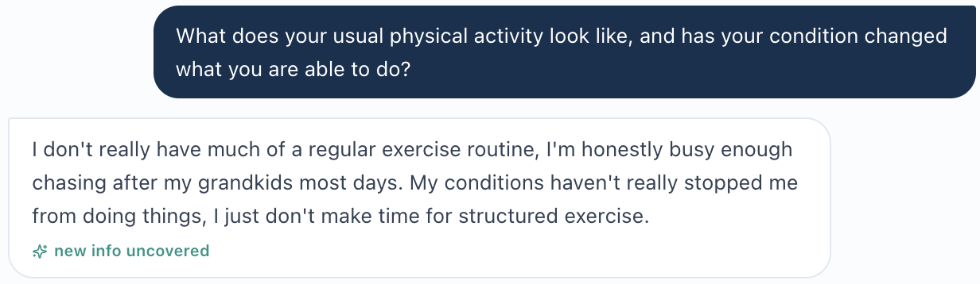
Original LM Tuesday interview: no routine exercise; childcare obligations. [Extracted unchanged from uploaded visit audit.]
Original 1D.6 grader request for “occasional walking.” [Extracted unchanged from uploaded visit audit.]

LM-TUE-04 | Displayed grade and visible penalty subtotal differ 0.1 point
PRIORITY: LOW STATUS: Scoring reconciliation; unverified
What the student saw or heard: AI grader displays 94.6% with 16 visible deduction items summing to 5.3 points.
What the reference / grader expected: Simple 100-point subtraction yields 94.7%; displayed is 94.6%.
Why this is a problem: Difference may arise from raw precision, hidden/scaled item or rounding; no scoring engine defect is demonstrated.
Suggested developer fix / retest: Review raw weights, normalized denominators, any unshown deductions and rounding. Preserve posted score pending validation.
Evidence source: Tuesday audit; feedback screenshots 01/03/04.

Visit conclusion / boundaries
The note met all four checklist competencies: CKD G3aA3 staging, established ASCVD/secondary prevention, appropriate priority ordering, and rationale. Other line-item feedback primarily concerns clinical language, guideline naming and supported SOAP detail.
Source report: LM Tue Initial Report.docx. Score and issue interpretations above are carried forward from this uploaded audit.

Linda Martinez — Wednesday 3-month follow-up
AI-grader: 83.4% (Solid) | Grouped issues/review items: 6 | Initial audit, not post-fix retest
ID | Issue | Priority | Source-based disposition
LM-WED-01 | LDL-C 76 mg/dL penalized against incorrect 86 mg/dL reference | High | Confirmed EMR–grader LDL mismatch
LM-WED-02 | Expected medication misses contradict adherence statement | High | AI-patient/EMR versus grader expectation conflict
LM-WED-03 | Home monitoring conflict and invented expected ranges | High | EMR/interview contradiction plus rubric-source question
LM-WED-04 | Grader transfers Tuesday fatigue/edema into Wednesday ROS | Medium | Temporal/history expectation mismatch; review
LM-WED-05 | Finerenone versus LDL optimization treated as exclusive priority | Medium | Clinical reasoning/rubric alignment review
LM-WED-06 | 0.1-point difference between posted grade and displayed deductions | Low | Scoring reconciliation; unverified

LM-WED-01 | LDL-C 76 mg/dL penalized against incorrect 86 mg/dL reference
PRIORITY: HIGH STATUS: Confirmed EMR–grader LDL mismatch
What the student saw or heard: Current Wednesday EMR lists LDL-C 76 mg/dL (previous 92) in key labs, lipid panel and supporting narrative; submitted SOAP also records 76.
What the reference / grader expected: Grader 2B.12 (−0.8) and 2B.15 (−0.2) insist LDL-C should be 86 mg/dL and treat the correct trend as wrong.
Why this is a problem: A chart-faithful LDL value is incorrectly penalized and may distort risk-priority assessment. The two affected deductions total 1.0 point.
Suggested developer fix / retest: Correct answer key to Wednesday learner-visible LDL-C 76. Regrade unchanged note and reassess any linked lipid-priority scoring without altering independently valid criteria.
Evidence source: Wednesday audit; EMR repeated lipid values and original feedback.

LM-WED-02 | Expected medication misses contradict adherence statement
PRIORITY: HIGH STATUS: AI-patient/EMR versus grader expectation conflict
What the student saw or heard: Patient explicitly reports taking all medicines as prescribed with no missed doses; Wednesday EMR also says excellent adherence.
What the reference / grader expected: Criterion 1B.4 (−0.2) expects approximately 1–2 isolated missed doses.
Why this is a problem: Deduction appears to favor non-elicited adherence problems over current interview evidence.
Suggested developer fix / retest: Inspect rubric/case state and grant credit for patient-confirmed zero misses when valid for this visit. Avoid retrospective insertion of scripted misses.
Evidence source: Wednesday audit; current interview and EMR.

LM-WED-03 | Home monitoring conflict and invented expected ranges
PRIORITY: HIGH STATUS: EMR/interview contradiction plus rubric-source question
What the student saw or heard: Patient reports not routinely checking home BP or glucose, and cannot provide recent home readings. EMR supplemental section lists a home BP average ~126/78, without a patient-confirmed origin.
What the reference / grader expected: Grader penalizes absent home BP/glucose frequency or ranges (1B.7–1B.10, 2A.6, 2C.3, 3C.4) and expects a home glucose range not established in current sources.
Why this is a problem: Student must preserve contradictory provenance rather than assert non-existent patient readings. A chart-only home BP value is not equivalent to verbal home monitoring.
Suggested developer fix / retest: Identify source of EMR BP value, fix any copied-forward home log, and grade accurate attribution of chart-only objective data alongside patient denial; do not mandate unverifiable glucose numbers.
Evidence source: Wednesday audit; original Wednesday interview.
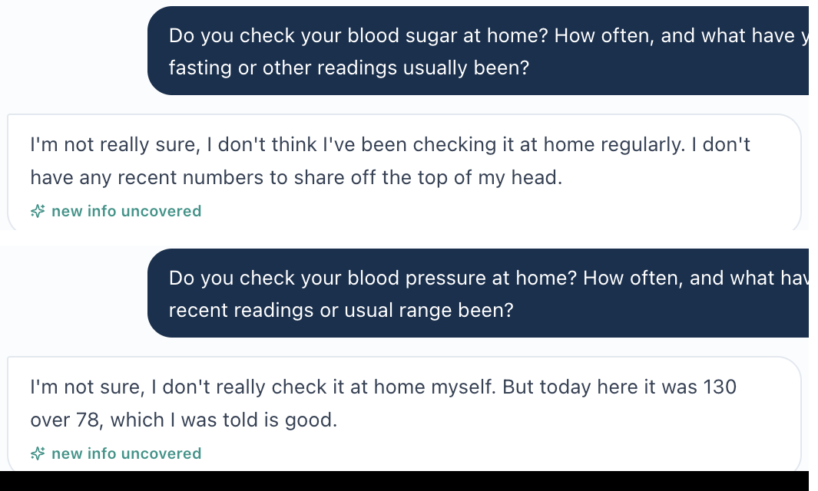
Original Wednesday interview: no reliable home glucose or BP readings. [Extracted unchanged from uploaded visit audit.]

LM-WED-04 | Grader transfers Tuesday fatigue/edema into Wednesday ROS
PRIORITY: MEDIUM STATUS: Temporal/history expectation mismatch; review
What the student saw or heard: Tuesday patient had intermittent daytime tiredness and positional leg swelling. On Wednesday patient reports feeling well and explicitly denies current leg swelling; current fatigue is not affirmed.
What the reference / grader expected: Feedback 1B.13 (−0.4) and 1B.14 (−0.2) require edema/fatigue details as though still current.
Why this is a problem: Previously positive symptoms can be cited as history but should not overwrite a later explicit denial.
Suggested developer fix / retest: Use visit-specific symptom state and explicitly differentiate historical positives from current negatives in expected rubric responses.
Evidence source: Wednesday audit; Tuesday history is longitudinal context only.

LM-WED-05 | Finerenone versus LDL optimization treated as exclusive priority
PRIORITY: MEDIUM STATUS: Clinical reasoning/rubric alignment review
What the student saw or heard: UACR remains 330 mg/g (A3) despite lisinopril 40 mg and empagliflozin 10 mg; K 4.8 mEq/L and eGFR ~50. LDL-C 76 mg/dL remains above stated secondary-prevention goal. Student discusses finerenone.
What the reference / grader expected: Criterion 3D.10 (−0.4) prefers lipid optimization as the single next highest-yield intervention.
Why this is a problem: Both residual-albuminuria therapy and ASCVD lipid optimization can be clinically supportable, with potassium and kidney-safety limitations for finerenone.
Suggested developer fix / retest: Allow evidence-based prioritized alternatives with clear safety and shared-decision rationale; clarify rubric if LDL optimization is intentionally required for this scenario.
Evidence source: Wednesday audit; A3 albuminuria, K and LDL source data.

LM-WED-06 | 0.1-point difference between posted grade and displayed deductions
PRIORITY: LOW STATUS: Scoring reconciliation; unverified
What the student saw or heard: The source audit sums 44 visible deductions to 16.5 points; displayed overall grade is 83.4%.
What the reference / grader expected: A simple 100-point calculation yields 83.5%, not 83.4%.
Why this is a problem: Unknown precision, weighting and unseen items could explain this; no numerical backend error has been proven.
Suggested developer fix / retest: Export raw criterion scores and normalization/rounding rules. Reconcile without inventing corrected grade.
Evidence source: Wednesday audit; full feedback deductions appendix.

Visit conclusion / boundaries
All four checklist priorities were addressed (improved albuminuria, BP attainment, residual cardiorenal risk, and next-intervention selection). Other genuine SOAP omissions include charted HR/BMI/lipid components, named guideline references and some documented immunization history. These are not automatically system defects.
Source report: LM Wed Initial Report.docx. Score and issue interpretations above are carried forward from this uploaded audit.

Linda Martinez — Thursday 6-month / final follow-up
AI-grader: 91.3% (Strong) | Grouped issues/review items: 3 | Initial audit, not post-fix retest
ID | Issue | Priority | Source-based disposition
LM-THU-01 | Demographic age remains inconsistent with DOB | High | Confirmed in supplied EMR; live verification needed
LM-THU-02 | Final follow-up title conflicts with “Initial” intake label | Medium | Confirmed in Word chart export; live verification needed
LM-THU-03 | Posted 91.3% differs from subtotal of 23 visible deductions | Low | Scoring reconciliation needed; unverified

LM-THU-01 | Demographic age remains inconsistent with DOB
PRIORITY: HIGH STATUS: Confirmed in supplied EMR; live verification needed
What the student saw or heard: Thursday chart header again states age 68 with DOB 03/12/1972 at 06/23/2026 encounter.
What the reference / grader expected: DOB implies age 54 on that date.
Why this is a problem: Cross-visit age discrepancy persists; it is the same underlying issue as LM-TUE-01 rather than proof of a separate root cause.
Suggested developer fix / retest: Use canonical age/DOB and confirm resolution in both Tuesday and Thursday interfaces; keep recurring report reference without duplicate tickets.
Evidence source: Thursday audit and EMR export; cross-reference LM-TUE-01.

LM-THU-02 | Final follow-up title conflicts with “Initial” intake label
PRIORITY: MEDIUM STATUS: Confirmed in Word chart export; live verification needed
What the student saw or heard: Top-level chart says “Thursday · Final Follow-Up,” while intake entry at 06/23/2026 08:50 is titled “Initial Ambulatory Care Pharmacist Visit.”
What the reference / grader expected: A current follow-up record should not appear to be an initial visit unless the intake wording is clearly identified as historical.
Why this is a problem: Ambiguous visit stage can confuse note documentation and grader assumptions about long-term transition.
Suggested developer fix / retest: Verify labels in live encounter, determine whether intake is historical, and correct/currently label metadata or contextualize the prior entry.
Evidence source: Thursday audit; current LM Thursday Word EMR.

LM-THU-03 | Posted 91.3% differs from subtotal of 23 visible deductions
PRIORITY: LOW STATUS: Scoring reconciliation needed; unverified
What the student saw or heard: Posted feedback is 91.3% (Strong); 23 visible deductions sum to 8.9 points.
What the reference / grader expected: Under an unweighted 100-point subtraction, 8.9 would produce 91.1%, not 91.3%.
Why this is a problem: Possible item weighting/rounding/missing adjusted credit is not resolved from feedback screenshots.
Suggested developer fix / retest: Inspect machine-readable raw scoring output and normalization; preserve 91.3% as reported until verified.
Evidence source: Thursday audit; four feedback screenshots and report deduction log.

Visit conclusion / boundaries
Reference checklist goals were met: cumulative improvement, comprehensive maintenance plan, and safe transition/continuity. Most of the 23 deductions concern wording, explicit attribution of treatment benefits, guideline names, obesity/ASCVD rationale, or lipid follow-up cadence—not demonstrated technical grading failures.
Source report: LM Thur Initial Report.docx. Score and issue interpretations above are carried forward from this uploaded audit.

Week 1 Closeout and Developer Handoff
Central finding: Multiple Wednesday source-to-grader discrepancies can penalize chart-faithful documentation. Separate these from true SOAP omissions and from unresolved metadata or scoring questions. Fix the data/reference alignment first, then rerun the nine encounter/score pathways using the existing transcript and SOAP evidence.

Cross-visit relationships
• MG: Tuesday follow-up timing mismatch; Wednesday seven-value lab key mismatch; no confirmed new Thursday issue.
• JW: Tuesday age/BSA/father-stroke conflicts persist into later visits; Wednesday adds lab/history grading mismatches and monitoring/tolerability source contradictions. Thursday home-device acquisitions resolve an apparent new-monitoring inconsistency but not Wednesday provenance.
• LM: Tuesday age/BSA conflicts recur; Wednesday confirms LDL reference error and patient-monitoring mismatches; Thursday notes the recurring age conflict, visit-stage label ambiguity, and score reconciliation. Later evidence supports CKD albuminuria improvement and safe maintenance planning.

Source inventory and audit limitations
Primary source documents: the nine uploaded “Initial Report” Word files for MG, JW and LM, plus “Week_3_VACS_Issue_Report_SAMPLE(2).docx” as formatting/organization guidance. The reports themselves cite or embed original AI-patient screenshots, grader screenshots and original live EMR captures when available. Where only the report’s text description of an EMR Word export was present, the analysis preserves that provenance; it does not mislabel export excerpts as independent live-browser proof.
No backend rubric, exact submitted machine-readable SOAP payload, full raw grading denominator or post-fix testing data were supplied for this consolidation. The individual encounter reports remain the detailed source for deductions not promoted to developer issues. No overall corrected score is calculated. Clinical facts are presented as simulated encounter data, not clinical advice for a real patient.
Prepared by Mitchell Bowers, PharmD Candidate, Class of 2027, D’Youville University School of Pharmacy

